Critical Incident Paper
The Global Financial Crisis of 2008: factors that led to the crisis
Mariia Lukashenko
ECO-416
Dr. Baranes
5/19/2026

The Global Financial Crisis of 2008 was the most severe financial breakdown since the Great Depression - it disrupted credit markets, destabilized major financial institutions, and exposed how deeply modern economies depend on the stability of banks, securities markets, and housing finance. Yet the crisis did not begin when panic became visible in 2008. By that time, the financial system had already spent years building up risk through expanding mortgage credit, rising leverage, and growing dependence on housing-related assets. Different schools of thought disagree on the mechanisms behind that process, but they overlap on several central points: risk-taking in the financial system became excessive, credit and debt expanded too far through housing, home prices became unsustainable, and large financial institutions became fragile because they were deeply connected to mortgage-related securities (Snowdon & Vane, 2005). This critical incident follows that consensus, while placing particular emphasis on the way prolonged easy credit and distorted incentives encouraged excessive borrowing, malinvestment, and false confidence across the financial system.

The build-up began during the long expansion in housing and mortgage credit that marked the late 1990s and early 2000s. Housing came to be seen not only as next life step, but as a safe appreciating asset and an increasingly normal source of household wealth. Between 1994 and 2004, the U.S. homeownership rate rose from 64 percent to 69 percent (Doms & Motika, 2006). At the same time, mortgage debt of U.S. households rose from 61 percent of GDP in 1998 to 97 percent in 2006. National home prices also rose much faster than usual, with major house-price indices showing a sharp increase before the market peaked in 2006 (Weinberg, 2013). This was not just a small change in one part of the economy - it showed that more credit, labor, and investment were moving into housing. Because of this, the boom looked like economic strength, even though it was already creating financial instability.

That expansion was reinforced by a credit environment that made borrowing unusually cheap and encouraged investors to search for higher returns. In June 2003, the Federal Open Market Committee lowered the target federal funds rate to 1 percent (Board of Governors of the Federal Reserve System, 2003). Low rates alone did not create the crisis, but they helped support the conditions under which mortgage borrowing expanded rapidly and riskier lending became easier to justify. As credit became more abundant, rising home prices seemed to validate the optimism. Borrowers believed refinancing would remain possible, lenders believed collateral values would keep improving, and investors treated mortgage finance as a dependable engine of growth. In that environment, the boom did not just increase prices - it changed expectations. The longer prices rose, the more normal and sustainable the system appeared.

The structure of mortgage finance was also changing in ways that weakened the older discipline of lending. In a traditional model, a bank that originated a mortgage often kept that loan on its own balance sheet and therefore had a strong incentive to evaluate whether the borrower could repay over time. In the early and mid-2000s, that model gave way to an “originate to distribute” system. Mortgages, including increasingly risky subprime loans, could be pooled together, converted into mortgage-backed securities, and sold to investors (Bernanke, 2007). The Federal Reserve’s own history of the crisis notes that private-label mortgage-backed securities became a major source of funding for subprime lending. Once that happened, mortgage origination increasingly became the first step in a fee-generating chain rather than the creation of a long-term asset that had to be monitored closely (Federal Deposit Insurance Corporation, 2017). The immediate incentive shifted toward volume. As a result, more credit flowed into housing precisely when housing already appeared to be the safest part of the economy.

That shift mattered even more because securitization made risky loans look diversified and liquid. Mortgage pools were divided into tranches with different seniority, then frequently repackaged again into collateralized debt obligations. Investors often relied less on the underlying quality of the mortgages than on the ratings attached to the final products. Those ratings became a central bridge between risky household debt and the broader financial system. But the process behind them was much weaker than many market participants assumed. In 2008, the SEC found that rating agencies had struggled with both the growing number and complexity of subprime RMBS and CDO deals since 2002, that none of the firms examined had specific written comprehensive procedures for rating such products, and that surveillance after the initial rating was weaker than the initial rating process itself (U.S. Securities and Exchange Commission, 2008). That finding matters because it means one of the main sources of confidence before the crisis was already under strain during the boom years, even while investors continued treating these securities as safe.

As mortgage risk moved outward from traditional banks, it did not disappear. On the other hand, it became tied to a wider shadow-banking structure built on leverage, maturity transformation, and short-term funding. Basically, long-term and often illiquid mortgage assets were increasingly being financed by institutions that depended on continuous market confidence. What looked like diversification often meant that risk was being repackaged and spread through a network that was highly connected but not very resilient (Adrian & Shin, 2009). The regulatory environment did not keep pace with that transformation. In 2004, the SEC adopted an alternative net capital framework that allowed certain large broker-dealers to use internal mathematical models to calculate capital requirements for market and credit risk, which appeared more modern and flexible (Kwak, 2012). In practice, it reflected a broader regulatory shift toward lighter supervision and greater reliance on firms’ own risk models during a period when the underlying assets were becoming harder - not easier, to value correctly.

By the middle of the decade, the financial system had therefore become dependent on a chain of assumptions that all pointed in the same direction. Housing prices would continue to rise. Mortgage defaults would remain limited. Highly rated securities would remain liquid. Short-term funding would remain available. Large institutions exposed to the same underlying asset class would remain stable because risk had supposedly been dispersed. But in reality, the same process that spread mortgage risk also made the system more synchronized. Banks, investment banks, structured-finance vehicles, money markets, and investors were increasingly exposed to the same housing boom, often through instruments whose safety depended on models, ratings, and refinancing conditions that only worked while prices kept rising. Once home prices stopped providing that protection, the weakness was no longer confined to mortgage borrowers - it was embedded in the structure of the financial system itself (Taylor, 2009)

For that reason, the crisis should be understood not simply as a sudden market collapse, but as the outcome of a long pre-crisis build-up. Easy credit helped fuel excessive borrowing. Rising housing prices made that borrowing look safe. Securitization weakened the incentive to screen and monitor loans carefully. Ratings overstated the safety of increasingly complex mortgage products. Regulatory change and weak oversight allowed leverage and short-term funding dependence to grow inside a highly interconnected system. The Financial Crisis Inquiry Commission later concluded that the crisis was avoidable and that warnings were missed or ignored (Financial Crisis Inquiry Commission, 2011). Seen in that light, the central problem is not only why the system collapsed in 2008, but why so many institutions had already come to depend on a structure that required ever-rising housing prices, abundant liquidity, and continued confidence in mortgage-backed securities in order to survive.

Critical Incident Overview

This critical incident examines the build-up to the 2008 financial crisis rather than the crisis and its aftermath. It argues that financial fragility developed gradually as easy credit, rising housing prices, securitization, and weak political and regulatory restraint reinforced one another. Lower borrowing costs encouraged more mortgage lending, expanding credit pushed housing demand and prices higher, and rising prices made weaker lending standards appear safe. Securitization intensified this process by expanding the flow of mortgage credit and spreading mortgage-related risk across the financial system. By the time the crisis became visible in 2007 and 2008, much of the instability had already been built into mortgage markets, structured finance, and the shadow-banking system.

Learning Objectives
By the end of this critical incident, readers should be able to:
- Explain how artificially cheap credit and rising house-price expectations created a self-reinforcing housing boom by distorting the relationship between saving, investment, and mortgage credit before the 2008 financial crisis.
- Understand how asymmetric information, leverage, and rising bankruptcy risk made the mortgage-finance system increasingly fragile once housing prices and credit conditions began to weaken.
- Use the Nordhaus political business cycle model to evaluate why short-run political and regulatory incentives made policymakers less willing to restrain mortgage-credit expansion, securitization, and weak oversight before the long-run risks became visible.

Questions
- Why did artificially cheap credit and rising house-price expectations generate a self-reinforcing and unsustainable housing boom?
- Why did asymmetric information, leverage, and rising bankruptcy risk make the pre-crisis mortgage-finance system increasingly fragile once housing and credit conditions began to weaken?
- Why did short-run political and regulatory incentives make policymakers less willing to restrain the credit and housing boom before its long-run risks became visible?

Answers to Questions

Question 1

Why did artificially cheap credit and rising house-price expectations generate a self-reinforcing and unsustainable housing boom?

Define
- Artificially cheap credit: Credit becomes artificially cheap when borrowing costs are pushed below the level that would normally balance real saving and investment.
- Self-reinforcing boom: A cycle in which easier credit raises demand, higher demand raises prices, and rising prices justify even more lending.
- Malinvestment: Investment that appears profitable during a credit boom but becomes unsustainable once credit conditions or expectations change.

Diagram

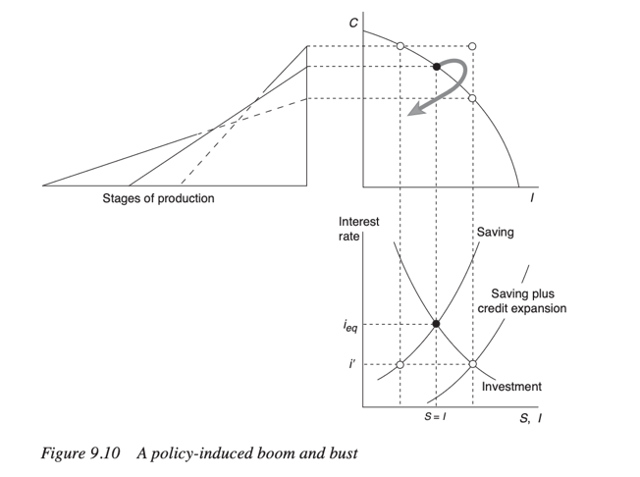

Figure 9.10 shows the boom as a movement away from a sustainable equilibrium. In the loanable funds part of the diagram, saving equals investment, at the equilibrium interest rate iₑq. This point represents a sustainable balance: investment is being financed by real saving. Then the diagram shows the market interest rate being pushed down to i′, below the equilibrium rate. At this lower rate, investment increases because borrowing is cheaper, but genuine saving does not increase in the same way. This creates a gap between actual saving and desired investment. The diagram labels this as saving plus credit expansion, meaning that the additional investment is not supported by real saving, but by new credit. The upper part of the diagram shows how this affects the structure of production. Lower interest rates make long-term investment projects look more profitable, so resources shift into longer and more interest-sensitive stages of production. For the 2008 crisis, we can see it in housing construction, mortgage lending, real estate services, and mortgage-backed securities. The economy appears to be expanding, but the expansion depends on credit conditions that cannot last.

Discuss

This diagram is highly applicable to the pre-2008 housing boom because the boom was driven by a false signal - the low interest rate made it look as if the economy had more real savings available for long-term investment than it actually did. In the diagram, this is shown by the movement from the equilibrium interest rate iₑq down to the lower rate i′. That lower rate encourages more investment, but the extra investment is not matched by genuine saving. Instead, it is supported by credit expansion.

This is exactly what happened in the housing market. Cheap mortgage credit allowed more households to borrow, which increased demand for houses. As demand rose, house prices increased. But then rising house prices created stronger expectations that prices would continue to rise. Borrowers believed that even risky mortgages were manageable because they could refinance later or sell the house at a higher price. Lenders believed that the house itself was good collateral because its value was rising. Investors believed that mortgage-backed securities were safe because the underlying assets seemed to be appreciating. This created the self-reinforcing cycle where cheap credit increased housing demand, higher demand raised house prices, rising prices made lenders and investors more confident. That confidence encouraged even more mortgage lending and securitization. Then the larger supply of mortgage credit pushed housing demand and prices even further upward. The process looked stable from the outside, but it was circular: rising prices justified more credit, and more credit helped produce rising prices.

The diagram also helps explain why the boom was unsustainable. The key problem is the gap between saving and investment. When S = I at the equilibrium interest rate, investment is supported by real resources. But when the interest rate is artificially lowered to i′, investment expands beyond actual saving. In the pre-crisis economy, this appeared as excessive mortgage borrowing, overbuilding in housing, and large investment flows into mortgage-backed securities. These activities seemed profitable because credit was cheap and home prices were rising, not because the underlying repayment capacity of borrowers had truly improved.

Mortgage-backed securities made this imbalance stronger. In a traditional mortgage system, lenders had more reason to check whether borrowers could repay. But securitization allowed lenders to originate mortgages and sell them into financial markets. This meant that the immediate incentive shifted toward creating more mortgages, because more mortgages meant more securities to package and sell. In the diagram’s terms, securitization helped extend the “credit expansion” part of the boom. It allowed investment in housing finance to keep growing even when genuine saving and borrower quality did not support that expansion.

The upper-left part of the diagram, showing the stages of production is also useful here. It shows that artificially low interest rates do not only increase total investment - they also change where resources go. In the 2008 case, resources shifted heavily toward housing, construction, mortgage origination, structured finance, and financial products linked to real estate. These sectors expanded because the price signals created by cheap credit made housing-related investment look safer and more profitable than it really was.

So, the answer to the question is that artificially cheap credit and rising house-price expectations reinforced each other. The cheap credit started the expansion by making mortgages easier to obtain. Rising house prices then made the credit expansion look justified. But because the boom depended on credit creation rather than real saving and sustainable repayment capacity, it produced malinvestment. Figure 9.10 shows this clearly: once investment is pushed beyond saving through credit expansion, the boom can continue for a while, but it rests on a distorted foundation. That is why the housing boom was both self-reinforcing and unsustainable (Snowdon & Vane, 2005).

Question 2

Why did asymmetric information, leverage, and rising bankruptcy risk make the pre-crisis mortgage-finance system increasingly fragile once housing and credit conditions began to weaken?

Define
- Asymmetric information: A situation where some participants know more about the true risk of loans or securities than others.
- Leverage: The use of borrowed money to increase investment exposure, which magnifies gains during booms and losses during downturns.
- Financial fragility: A condition where small shocks can produce large instability because institutions are highly leveraged and interconnected.

Diagram

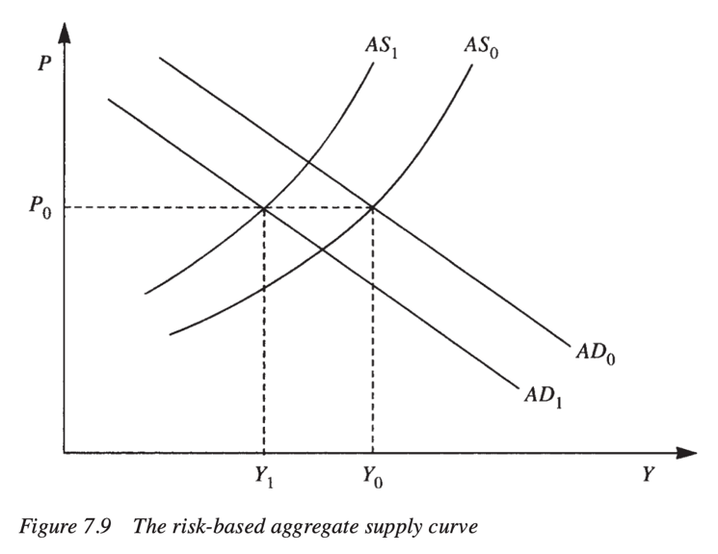

This diagram shows how higher risk can reduce economic activity even if the economy’s physical resources have not disappeared. The economy initially operates at output Y₀ and price level P₀, where aggregate demand AD₀ intersects aggregate supply AS₀. Then risk rises: in the diagram, this is shown by the aggregate supply curve shifting left from AS₀ to AS₁. At the same price level P₀, output falls from Y₀ to Y₁. This movement shows that higher risk makes production, lending, and investment more difficult. Firms and financial institutions become less willing to expand, credit becomes tighter, and the economy can no longer support the same output level under the same conditions. The diagram also shows aggregate demand shifting from AD₀ to AD₁. This captures how weakening confidence and tighter credit can reduce spending and investment. For the 2008 crisis, this matters because housing weakness did not stay inside the housing market - once mortgage risk was reassessed, it affected bank balance sheets, securities markets, lending conditions, and broader demand.

Discuss

This diagram is useful because the pre-crisis mortgage-finance system was fragile before the collapse became obvious. During the boom, mortgage-backed securities made risk look diversified and manageable. But once housing and credit conditions began to weaken, the system became exposed to rising bankruptcy risk. Figure 7.9 helps explain that process because it shows how a rise in risk shifts the economy away from the stronger output position Y₀ toward the weaker position Y₁.

The first issue was asymmetric information. Mortgage originators often had better information about borrower quality than the investors who eventually bought mortgage-backed securities. A lender might know that a borrower had weak income documentation, a high debt burden, or a risky adjustable-rate mortgage. But once that mortgage was pooled, tranched, rated, and sold, the final investor often saw only the security’s rating and expected return. The true quality of the underlying loans became harder to observe. This matters because the economy initially behaves as if risk is low. That is represented by the original aggregate supply curve AS₀ and output level Y₀. At this stage, financial institutions are willing to lend, investors are willing to buy mortgage-backed securities, and credit continues flowing into housing. But that stability depends on the belief that the securities are safe and liquid. Once doubts appear, the risk environment changes. In the diagram, that is the shift from AS₀ to AS₁.

Leverage made this shift much more dangerous. Highly leveraged institutions could hold large amounts of mortgage-related assets with relatively little equity. During the boom, this made profits look larger because rising asset prices generated high returns on a small equity base. But once mortgage values weakened, leverage magnified losses. Even a small decline in the value of mortgage-backed securities could create serious solvency concerns for institutions that had borrowed heavily to hold them.

This is where bankruptcy risk becomes central. If borrowers begin to default, the cash flows supporting mortgage-backed securities weaken. If those securities lose value, the institutions holding them face losses. If those institutions are highly leveraged, losses can quickly threaten their ability to repay their own creditors. So the original mortgage risk moves through several layers: from household borrowers, to mortgage pools, to securities, to leveraged financial institutions, and then to the broader credit system.

The diagram’s movement from Y₀ to Y₁ captures this broader effect. Rising risk does not only change the value of one asset. It reduces the willingness of financial institutions to lend and invest. Credit tightens. Firms and households face harder borrowing conditions. Financial institutions become more defensive. In macroeconomic terms, the supply side of the economy becomes more constrained because finance is no longer supporting the same level of activity. At the same time, aggregate demand can also shift left from AD₀ to AD₁, because weaker credit conditions reduce spending, investment, and confidence.

This is why the system was fragile rather than simply risky. A risky system can absorb losses if risks are transparent, capital buffers are strong, and institutions are not too interconnected. But the pre-crisis mortgage-finance system had the opposite structure. Risk was hidden by asymmetric information, amplified by leverage, and spread across many institutions through securitization and shadow banking. Many firms were exposed to the same underlying housing market while believing that their exposures were diversified.

The diagram therefore helps answer the question by showing the effect of rising perceived risk. Once housing and credit conditions began to weaken, the financial system could no longer stay at the high-output, low-risk position represented by Y₀ and AS₀. The reassessment of mortgage risk shifted the economy toward AS₁, where the same price level was associated with lower output Y₁. In the context of 2008, this means that hidden mortgage risk became a broader constraint on lending, investment, and economic activity.

So, asymmetric information made it difficult to see the true quality of mortgage assets. Leverage made even small losses dangerous. Rising bankruptcy risk turned mortgage weakness into institutional fragility. The key point is that the weakening of housing conditions did not create fragility from nothing - it revealed fragility that had already been built into the structure of mortgage finance (Snowdon & Vane, 2005).

Question 3

Why did short-run political and regulatory incentives make policymakers less willing to restrain the credit and housing boom before its long-run risks became visible?

Define
- Political business cycle: The idea that policymakers may favor short-run economic expansion because its benefits are visible before the long-run costs appear.
- Regulatory forbearance: A reluctance to impose strict regulation even when financial risk is building.
- Short-run incentives: Immediate gains such as rising homeownership, higher house prices, stronger growth, and financial-sector profits.

Diagram

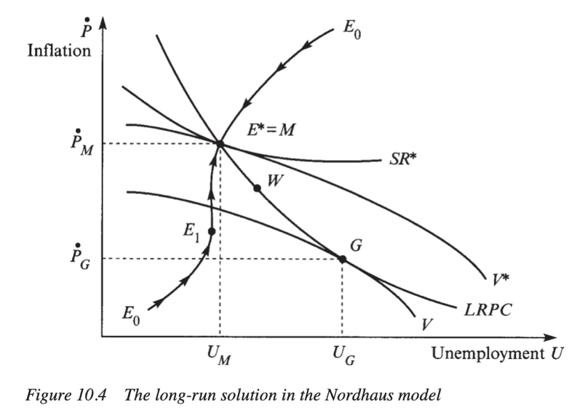

This diagram shows the political tension between short-run gains and long-run stability. In the original Nordhaus model, policymakers may try to move the economy toward lower unemployment before the full inflationary cost becomes visible. The diagram shows a preferred short-run point, such as G, where unemployment is lower at Uᴳ and inflation is lower at Ṗᴳ. This looks politically attractive because it gives voters a stronger economy in the short run. But the long-run equilibrium is shown around E* = M, with unemployment at Uᴹ and inflation at Ṗᴹ. The movement from the short-run position toward the long-run position shows that expansionary policy cannot permanently avoid adjustment. Expectations change, inflation rises, and the economy moves back toward a less politically convenient long-run outcome. For the 2008 crisis, the issue was not mainly consumer-price inflation. Instead, the short-run “gain” was the housing and credit boom: rising homeownership, strong housing demand, expanding mortgage credit, and financial-sector profits. The long-run “cost” was financial fragility, excessive leverage, weak underwriting, and dependence on rising house prices.

Discuss
Figure 10.4 is useful because it explains why policymakers may tolerate a boom that is politically attractive in the short run but unstable in the long run. In the diagram, point G represents the kind of outcome that looks desirable politically: unemployment is lower, the economy appears stronger, and the immediate costs are not yet fully visible. But the model shows that this position is not sustainable. Over time, the economy moves toward the long-run point E* = M, where the delayed costs of the earlier expansion become visible
This logic applies closely to the pre-2008 housing and credit boom. Before the crisis, policymakers and regulators saw many short-run benefits from easy credit. More households could buy homes. Rising house prices made homeowners feel wealthier. Construction, real estate, finance, and consumer spending were supported by mortgage credit. Financial institutions earned high profits from originating, securitizing, rating, and trading mortgage-backed securities. Politically, these outcomes looked like success. In the Nordhaus model, policymakers have an incentive to move toward the politically attractive short-run position because the benefits arrive first. In the 2008 case, the equivalent movement was not mainly from high unemployment to low unemployment, but from stricter credit conditions to easier credit conditions. Easier mortgage lending produced visible gains: more borrowing, more home purchases, higher asset prices, and stronger growth. These benefits were immediate and easy to defend.
By contrast, the long-run risks were much harder to see. Stricter mortgage standards, tighter capital rules, or stronger oversight of securitization would have imposed immediate costs. They could have slowed housing demand, reduced mortgage access, lowered financial profits, and made the economy look weaker in the short run. The benefits of stricter regulation would have been mostly invisible because they would have taken the form of a crisis that did not happen. This created a strong political asymmetry: the costs of restraint were obvious, but the benefits of restraint were delayed and uncertain.
The diagram’s movement toward E* = M helps show why that short-run logic was dangerous. In the original model, the economy cannot permanently stay at the attractive short-run point because expectations adjust and inflation rises. In the pre-2008 case, the housing boom also could not stay at its attractive short-run point because the financial system was becoming more fragile. The adjustment did not appear as ordinary inflation. It appeared as asset-price inflation, excessive mortgage debt, rising leverage, and growing dependence on housing collateral.
Regulatory incentives reinforced this problem. During the boom, mortgage-backed securities and other structured products were often presented as financial innovation. They seemed to spread risk across markets and make the financial system more efficient. Regulators increasingly relied on ratings, internal risk models, and market discipline. That made it easier to justify a lighter regulatory approach. As long as housing prices kept rising and defaults remained limited, the system appeared stable.
But this apparent stability was similar to the temporary short-run position in the Nordhaus model. It looked attractive because the costs had not yet arrived. Under the surface, mortgage quality was weakening, leverage was rising, and shadow-banking institutions were becoming more dependent on short-term funding. The long-run risks were accumulating even while the short-run outcomes looked successful.
So, the answer to the question is that policymakers were less willing to restrain the boom because the boom produced immediate political and economic benefits, while the dangers were delayed. In the 2008 case, the short-run benefits were rising homeownership, rising house prices, and financial profits. The long-run costs were excessive leverage, distorted mortgage lending, and systemic fragility. The model helps show why restraint was unlikely before the risks became visible: acting early would have been politically costly, while not acting allowed the boom to continue (Snowdon & Vane, 2005).
Epilogue
The aftermath of the 2008 crisis showed that the incident was not just a housing-market correction, but a failure of the wider financial system. As home prices fell and mortgage defaults rose, mortgage-backed securities lost value, and many highly leveraged institutions came under pressure. Because banks and shadow-banking institutions were closely connected through securitization, short-term funding, and shared exposure to housing, losses spread quickly beyond the mortgage market.
The impact of the crisis was severe - it weakened credit markets, damaged major financial institutions, and forced policymakers to rethink how financial stability should be protected. After 2008, regulation became more focused on bank capital, liquidity, systemic risk, shadow banking, and the dangers of excessive leverage. The crisis also changed economic thinking by showing that low inflation and steady growth do not necessarily mean the economy is safe.
What came next was a stronger recognition that financial fragility often builds quietly during booms. Rising asset prices, easy credit, and confidence can make risk look normal until the system is already vulnerable. The main lesson of the incident is that crises are not only about the moment of collapse - they are also about the years of hidden risk-taking that make collapse possible.

References
Adrian, T., & Shin, H. S. (2009, July). The shadow banking system: Implications for financial regulation (Staff Report No. 382). Federal Reserve Bank of New York. https://www.newyorkfed.org/medialibrary/media/research/staff_reports/sr382.pdf
Bernanke, B. S. (2007, September 20). Subprime mortgage lending and mitigating foreclosures. Board of Governors of the Federal Reserve System. https://www.federalreserve.gov/newsevents/testimony/bernanke20070920a.htm
Board of Governors of the Federal Reserve System. (2003, June 25). FOMC statement. https://www.federalreserve.gov/boarddocs/press/monetary/2003/20030625/default.htm
Brunnermeier, M. K. (2009). Deciphering the liquidity and credit crunch 2007–2008. Journal of Economic Perspectives. https://doi.org/10.1257/jep.23.1.77
Doms, M., & Motika, M. (2006, November 3). The rise in homeownership. FRBSF Economic Letter. Federal Reserve Bank of San Francisco. https://www.frbsf.org/research-and-insights/publications/economic-letter/2006/11/the-rise-in-homeownership/
Duca, J. V. (2013, November 22). Subprime mortgage crisis. Federal Reserve History. https://www.federalreservehistory.org/essays/subprime-mortgage-crisis
Federal Deposit Insurance Corporation. (2017). Crisis and response: An FDIC history, 2008–2013: Chapter 1, Origins of the crisis. https://www.fdic.gov/media/18636
Financial Crisis Inquiry Commission. (2011). Conclusions of the Financial Crisis Inquiry Commission. https://fcic-static.law.stanford.edu/cdn_media/fcic-reports/fcic_final_report_conclusions.pdf
Gorton, G. B. (2008). The subprime panic (NBER Working Paper No. 14398). National Bureau of Economic Research. https://doi.org/10.3386/w14398
Gorton, G., & Metrick, A. (2012). Securitized banking and the run on repo. Journal of Financial Economics. https://doi.org/10.1016/j.jfineco.2011.03.016
Kwak, J. (2012, January 30). What did the SEC really do in 2004? The Baseline Scenario. https://baselinescenario.com/2012/01/30/what-did-the-sec-really-do-in-2004/
Taylor, J. B. (2009). The financial crisis and the policy responses: An empirical analysis of what went wrong. National Bureau of Economic Research. https://doi.org/10.3386/w14631
U.S. Securities and Exchange Commission. (2008, July 8). SEC examinations find shortcomings in credit rating agencies’ practices and disclosure to investors. https://www.sec.gov/news/press/2008/2008-135.htm
Weinberg, J. (2013, November 22). The Great Recession and its aftermath. Federal Reserve History. https://www.federalreservehistory.org/essays/great-recession-and-its-aftermath

